
Year 1 Homework Grid Earn more
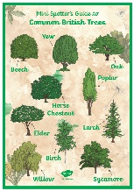  A Walk in the Woods  Go for a walk in the woods and use the identification sheet to name some trees. | Shape Hunt  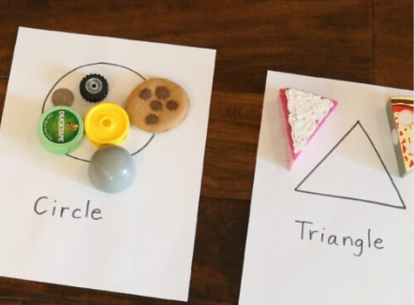  How many 2D shapes can you spot around your home? | 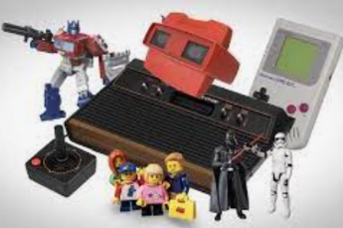  Old Toys  Ask your family about the toys they used to play with when they were your age. | 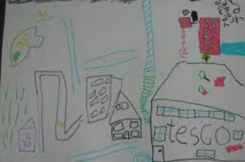  Mansfield  Go for a walk with your family around your home and draw a map of what you see.
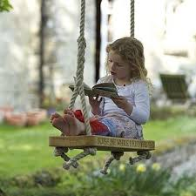  Reading  Read your favourite book to a pet, a family member or in an unusual place! | Natural Art  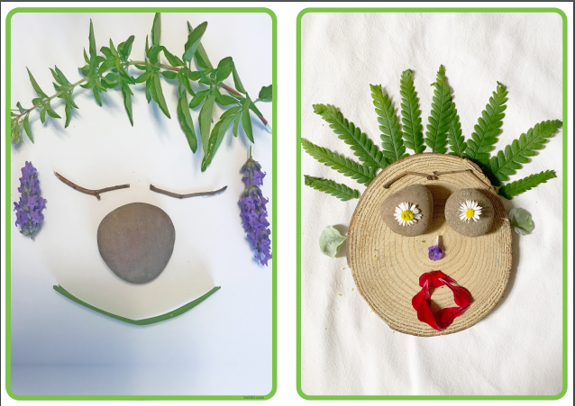  Go outdoors and create picture or pattern with natural resources. | Create a Character    Draw or make a character for  a story. | Autumn Scavenger Hunt  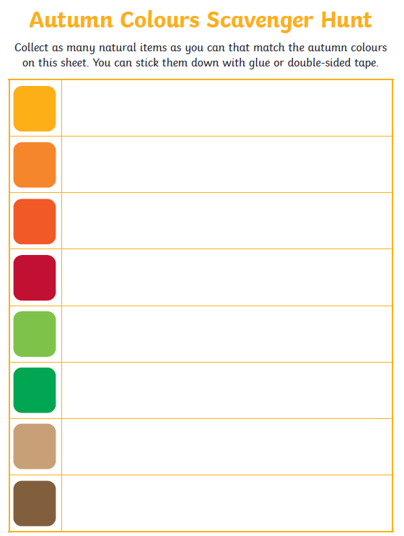  Use the sheet and hunt for items of different autumn colours.
September Challenge    Play a board game with your family. | October Challenge    Make a Halloween Treat with your family.  Extra DOJO opportunity  You could also write a recipe. | November Challenge    Make a firework model or picture  Extra DOJO opportunity  You could also write a poem. | December Challenge  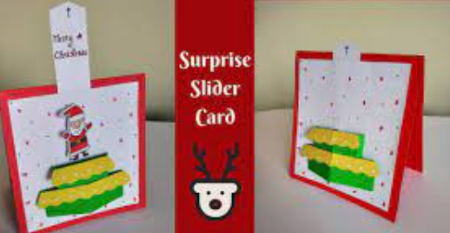  Make a moving Christmas card.

Send photos of what you have done or bring your homework in to school to earn extra Dojo points.

