
Year 1 Spring Homework Grid Earn more
A Spring Walk  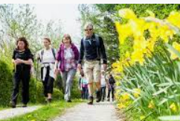  Go for a spring walk with your family, what flowers can you find? | 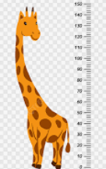  Measures  Can you find items in your home that are different lengths and heights? What is the tallest and shortest? Find a way of recording your findings. | History in the Past      Ask your family about the clothes they used to wear when they were growing up. What was their home like? What was it like at school? | Map work    Find out how many Continents and Oceans there are in the World. Can you remember and name them all? Have fun using an Atlas.
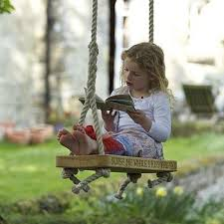  Reading  Read your favourite books to a pet, a family member or in an unusual place! Can you say what you like about them? | 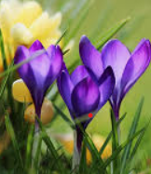  Plants  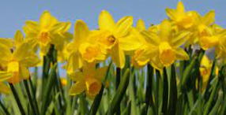  Plant some seeds and watch them grow. Keep a plant diary of what you see. | Photography    Take photos!  Follow our Computing theme and capture digital images.  Can you take photos of your family, a special day out or a fun activity? Remember to ask for permission first! | Puppets  Can you design and create your own puppet? You could make a shadow puppet, stick puppet or a paper puppet. Perform a puppet show!  
January Challenge    It’s a New Year…  try a new skill.  Is there something that you’ve wanted to learn how to do? Give it a go! | February Challenge    Make pancakes with your family. What is your favourite topping?  Extra DOJO opportunity  You could also write a recipe. | March Challenge  Make an Easter model or picture.    Extra DOJO opportunity – could you write an Easter poem, song or rap? | April Challenge  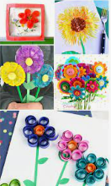  Make a 3D sculpture of a spring flower.
Send photos of what you have done or bring your homework in to school to earn extra Dojo points.

