Early Years Foundation Stage Offer

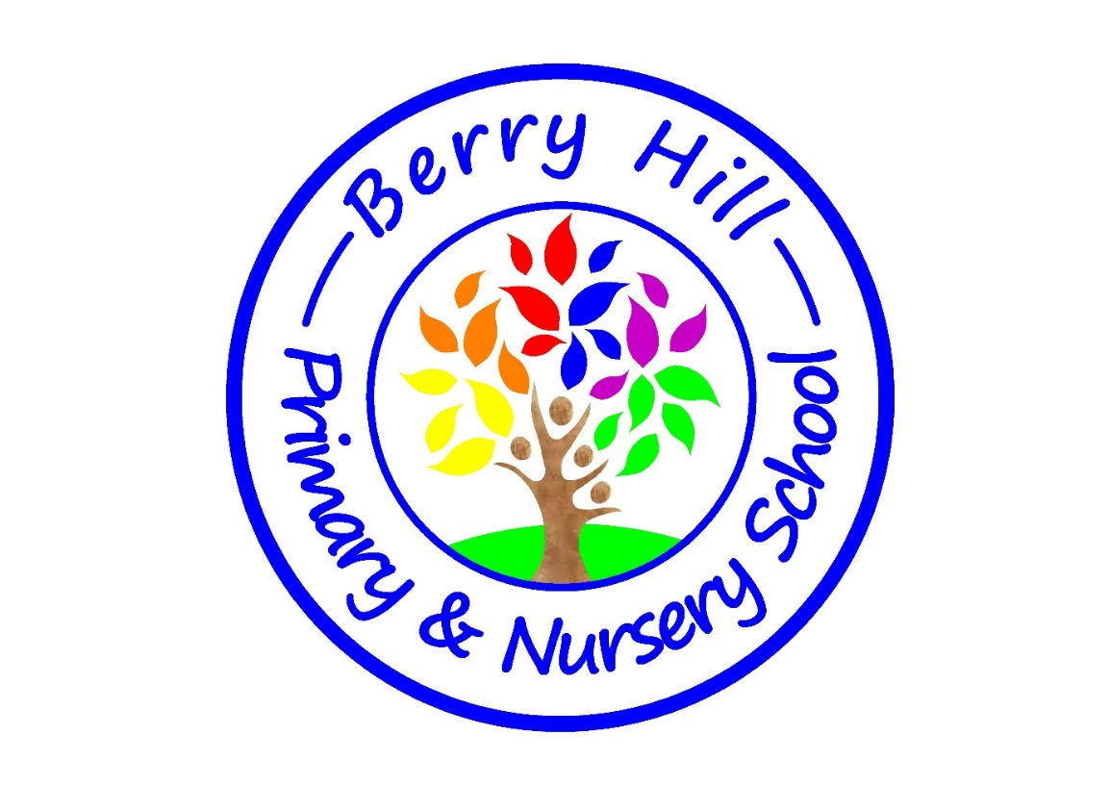

Berry Hill Primary School EYFS ethos and vision
At Berry Hill Primary School, our vision is a simple one: Be Kind, Work Hard, Be Brave. We want to help our children to know the importance of kindness, hard work and being brave. We support children to develop kindness and respect for themselves, others and their environment. Each child is unique and we aim to harness this and support our children to be confident, independent, inquisitive learners who can persevere and be resilient. We know that happy, cared for children thrive and are motivated to learn. We aim for all our children to feel a sense of belonging and pride in their school and in themselves. We aim to create an enabling environment where there is no lid put on learning and all children are supported and challenged. We will be the facilitators of this and provide opportunities and possibilities for them. We have good partnerships with our Families and community and between us, we will scaffold and support our children to grow, thrive and be the very best they can be.
Created by the EYFS team of 2023/24

Seven Features of Effective Practice
- The best for every child
- High quality care
- The curriculum ( what we want children to learn)
- Pedagogy ( helping children to learn)
- Assessment (checking what children have learnt)
- Self-regulation and executive function
- Partnership with parents

The best for every child
At Berry Hill we believe all children deserve to have an equal chance of success and strive to support each individual to succeed and become the best they can be whatever their starting points. We do this by providing high quality early education that equips children with all the skills needed both socially and academically. We aim to identify Special Educational Needs and children who are slower graspers as early as possible so that we can put support in place to ensure that everyone reaches their full potential.
High Quality Care
We know that children learn best when they are comfortable, safe and secure, both at home and at school. It is only when children feel comfortable that they are willing and able to be curious, take risks and try new things which will equip them with new learning and skills and allow them to embed this learning. We ensure all practitioners in our early years setting have a good understanding of what young children need to develop, know children well and care for them. This ensures that high quality care is consistent. There are designated staff for each class and in F1, children have a key adult that they will meet with in small group sessions. We will meet children where they are in terms of toileting, self-care, self-regulation and learning and development and support them individually on their journey to independence working closely with families to get the best for every child.
The Curriculum
Our children at Berry Hill bring with them many strengths and experiences ( that make up their cultural capital) which we take into account when we plan our curriculum. We know that one size does not fit all and along with the strengths we look at the gaps and barriers to learning to create a bespoke curriculum for our children. We follow the EYFS statutory guidance for this and the non- statutory guidance ‘Development Matters.’
We create a curriculum which is ambitious and allows children to develop depth in learning. We have developed careful sequencing which will help children to build their learning over time. We plan in experiences, activities, teaching and provision that help children to make links and for new learning to be embedded. We are responsive to children’s interests and know that their learning is often driven by this.
Throughout F1 and F2 we use carefully chosen high quality texts on which to build our curriculum. We know that these will capture children’s interests and introduce new vocabulary. Alongside these texts, we read from our reading spines daily that include a variety of fiction, non-fiction, poetry, rhyme and stories from different cultures.
We know that children need to develop their prime areas of learning (Communication and Language, Personal, social, Emotional Development and Physical Development) to support them in their specific areas of learning ( Literacy, Maths, Knowledge and Understanding of the Word and Expressive Arts and Design) . We ensure that there is a focus on this in F1 and that we also continue to give children opportunities to build, develop and embed the prime areas throughout their time in the EYFS. These are the foundations we build on to develop solid learning, development and skills. This is why we are called ‘The Foundation Stage’.
Pedagogy
Effective pedagogy is a mixture of different approaches. Children learn through play, by adult modelling, by observing each other, through guided learning and direct teaching. At Berry Hill, we ensure there is a good balance of these approaches and that play is at the heart of all we do. Within our timetables, we ensure children have a good amount of uninterrupted time in play and that practitioners are available and supporting them with this as much as possible. We ensure all staff have a good understanding of what quality interactions look like and how to achieve these to equip, embed and enrich children’s learning through play.
We have carefully organized enabling environments for high quality play. Children cannot help but be funneled into learning and we ensure that our continuous provision supports and extends all children and puts no ceiling on their learning. We know that children learn best when they have access to good quality provision both inside and outside and the freedom to choose where they play and learn. We facilitate free flow between our indoor and outdoor learning environments as much as possible.
Assessment
Assessment in the early years is about noticing what children can do and what they know in order to support their next steps. At Berry Hill our early years staff have a good knowledge of child development to enable them to do this effectively for children. Assessment should not take practitioners away from children for long periods of time.
Whilst there is a real emphasis on not collecting lots of evidence or data, we will use the following tools for formative assessment to support our professional judgements and discussions to understand where children are and support their development moving forward.
- Individual Busy books to capture the journey of learning the children take.
- F2 independent writing books to evidence progression in children’s mark making and writing.
- Individual learning squares displayed in the classroom to celebrate independent pieces of work.
- Reading log in F2 recorded three times a week.
- Ongoing phonic assessment and catch up
- Ongoing termly math assessment.
We will record summative data on Eaz Mag at key points in the year reporting on all 7 areas of learning. This will be done using a flat progress marker of ‘on track/ not on track’. Where children are not on track, we will provide interventions within play to support them on getting to ‘on track’ and close the gap quickly.
Baseline
In F1, we aim to provide children with an entry baseline assessment within 6 weeks of their starting date as long as wellbeing and involvement levels are high. Where they are not and children are still settling, this may take longer.
In F2, we complete the statutory NFER baseline test within the first half term.
EYFSP ( Early Years Foundation Stage Profile)
At the end of F2, it is a statutory requirement that we assess all children against the 17 early learning goals. They will have met the goal or not met the goal. To achieve a good level of development (GLD) children must have met the goal in the 3 prime areas ( Communication and Language, Personal, Social, Emotional Development and Physical Development) and the 2 specific areas of Literacy and Maths.
Self Regulation and Executive Function
Self-regulation and executive function are huge parts of our curriculum and underpin everything we do. These aspects are how we build lifelong learners and well rounded, caring people. They link to our characteristics of effective learning (playing and exploring, active learning and creating and thinking critically.)
Self-regulation and behaviour
Before children are able to regulate their emotions and feelings themselves, they may need support with co- regulation and in naming and understanding feelings. If a child is upset or angry or behaving in a way that isn’t appropriate, we will support them with thinking time and may use our Take Five breathing techniques to provide distraction or soothing activity to support with regulation. Once they are calm we will talk about what happened, how they felt and if there was a way they could have dealt with it differently. Over time, they will learn strategies and techniques that work for them to help self-regulate and we see that negative behavior patterns change. Children are able to make good choices quicker and understand the impact of their actions.

Partnership with Parents
At Berry Hill we know that for children to thrive it is important that parents and school have a strong, trusting, respectful partnership. We all hold different parts of the puzzle for a child and we need to bring these together to support the whole child. We know that where children are supported at home to play, read, chat and learn there is a significant and positive impact. As a school, we offer support to parents and provide regular information about how children are doing and how parents can support through our Class Dojo page. We aim to foster this partnership and hope that it will continue to grow and thrive through school to support every child on their journey of learning.

