

Anti-Bullying Policy

Child friendly version

At Berry Hill, we care about everyone and promise to keep everyone safe, happy and free from bullying. Bullying hurts and we want our school to be a place where every person feels cared for, respected, and included.

What is Bullying?

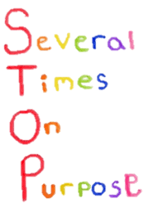
Bullying means being unkind on purpose, over and over again, to someone. It can be with words, actions, or online. Remember, if it's not friendly, it's not okay! We don't want anyone to feel sad, scared, or left out. We always use the STOP acronym to help us to understand when it might be bullying…


Who can you ask for support?
We have some fantastic people who can support you in our school if you see bullying or feel bullied. They will listen and help you, and they are:

Trusted Adults – Your teachers, teaching assistants, sports coaches and lunchtime playworkers are always here to listen and make things right.

Friends – Your classmates are your friends, and they can support you too.

Class Ambassadors -Our class ambassadors will help you to find the right person to speak to.

School Counsellors – Our school council talk about how to make sure everybody is happy in school and how to make sure bullying is always dealt with quickly.

Worry boxes -There is a worry box in every classroom, there is one in the school hall and there is even one online. Make sure you write down your worry about bullying if you don’t feel brave enough to speak to somebody
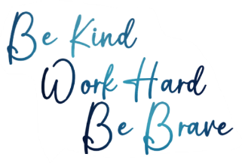


Remember, at Berry Hill, we believe in treating everybody with respect, and treating everybody with kindness. You should always think carefully about how to include others and to make sure nobody is ever left out!

Tell Someone – If you see bullying, don't keep it a secret. Tell a grown-up you trust.


Listen to Someone – Listen to anyone that feels upset to find out what’s wrong and get the right help from a grown up.

Preventing Bullying

We don't just stop bullying when it happens. We work hard to stop it happening in the first place. We talk about lots of these topics in our PSHE lessons and assemblies- lessons that help us learn about diversity and bring us together as a community. We talk about what bullying is and how we can all be friends. We learn about what good friendships and relationships look like.

Reporting Bullying
If you see bullying, don't be scared to tell.

You can:

Tell a Grown-Up – Your parents, teachers, or any trusted adult will help.

Use Your Worry Box – We have a special box to drop notes in if you don't want to talk directly.

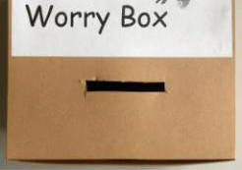


Online Safety – If you see online bullying, tell your parents or a trusted adult (like your teacher, teaching assistant or lunchtime supervisor), and they'll take care of it. Remember, if you are worried about how somebody is speaking with you online, you can make a report to CEOP through the school website.

If you make a report to a grown up in school, they will work with you to investigate what has happened. They will speak to people who might have seen the bulling and will decide what support might be needed to deal with the situation.


Consequences

Bullying is not allowed here, and we take it very seriously. If someone is repeatedly unkind, we do something about it and they will face consequences like:

A meeting with parents– We'll have a chat with the person and their parents and help them understand why bullying is not okay and find out what help they need. We tell them that it needs to stop.

Restorative Acts- If a child hurts someone, they will apologise and make things right. It is important that the person saying sorry knows and understands what they are sorry for and that the person receiving the sorry accepts the apology. That way we can all move forward.

R.E.D cards – If someone has hurt someone, they will receive a red card and will work on making things better whilst missing their breaktime. They will speak with SLT.

Bullying Log – all reports of bullying are recorded on the school log so that we can keep an eye on who is hurting others and how many times it has happened.
Celebrating Friendship

We love our school, and we want it to be a place full of happiness and friendship. Let's work together to make sure everyone is safe, respected, and enjoying our breaks and learning. Remember, kindness makes us all shine!

Inclusion and Diversity

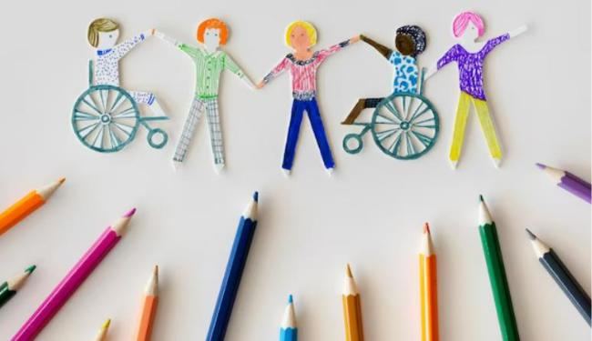

We are all unique and special in our own ways. We celebrate and respect our differences, and nobody should be bullied for who they are. Our school welcomes everyone, no matter their background, abilities, or interests.

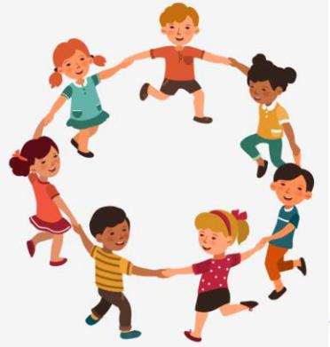
By following this policy, we can make sure that our school is a safe and happy place for everyone. Together, we can say NO to bullying and YES to friendship, kindness, and love!

