Personal, Social, Health and Economic (PSHE) Education Policy
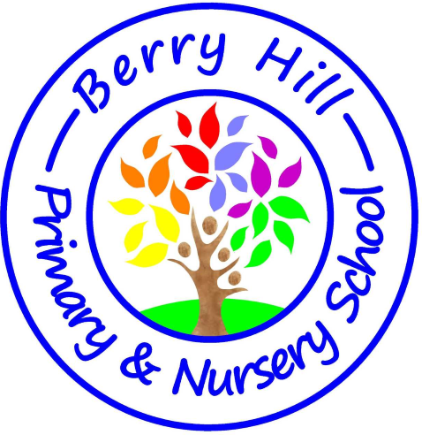

Berry Hill Primary School

Approved by: Full Governing Body
Approval date: January 2026
Next review due: September 2028

1. Aims
At Berry Hill Primary School, personal, social, health and economic (PSHE) education plays a vital role in developing the whole child and preparing pupils for life in modern Britain and beyond.
Our PSHE curriculum is rooted firmly in our school ethos:
Be Kind. Work Hard. Be Brave.
We aim to produce outstanding individuals who understand the importance of kindness, hard work and bravery, and who leave Berry Hill Primary School with a strong sense of responsibility to make positive contributions to society.
Through PSHE, we aim to help pupils:
- Develop kindness through empathy, acceptance, respect and thoughtful action
- Build emotional intelligence, including resilience, tolerance and understanding
- Develop the confidence and bravery to express themselves, ask for help and do what is right
- Gain the knowledge and skills to make safe, informed and responsible decisions
- Understand how to stay physically and mentally healthy
- Develop positive relationships and respect for diversity
- Become confident communicators, able to present, debate, reason and explain with clarity and conviction
- Understand democracy, British values and how to contribute positively to school life and the wider community
Our PSHE curriculum supports our wider vision of preparing pupils for a rapidly changing world, including one shaped by advances in Artificial Intelligence. While AI may provide information, it cannot replace the uniquely human skills of communication, empathy, moral judgement and social responsibility. Developing these skills is central to our PSHE provision.
The curriculum is underpinned by Berry Hill Primary School’s DREAM curriculum drivers: Diversity, Resilience, Ambition, Morality and Empowerment.

2. Statutory requirements
PSHE is a non-statutory subject. However, there are aspects of it that we are required to teach.
As a maintained primary school, we must teach:
- Relationships education under the Children and Social Work Act 2017, in line with statutory guidance
- Health education under the same statutory guidance
In addition, pupils in the Early Years Foundation Stage (EYFS), including Nursery and Reception, are expected to learn personal, social and emotional development (PSED) as set out in the EYFS statutory framework. PSHE learning in EYFS is delivered using the I Decision scheme and is embedded through continuous provision, adult-led activities and structured discussion.

3. Content and delivery

3.1 What we teach
Berry Hill Primary School delivers PSHE and Relationships and Health Education (RHE) through a carefully sequenced, age-appropriate curriculum.
- PSHE and RHE are taught weekly using the I Decision scheme
- Content fully meets statutory requirements for relationships and health education
- Learning is reinforced through assemblies, themed weeks and enrichment opportunities
- External visitors, such as the NSPCC and local PCSOs, support and enhance learning where appropriate
Further details of the statutory relationships, health and sex education content, including parental consultation, the right to withdraw from non-statutory sex education and the use of external providers, can be found in the school’s Relationships and Sex Education (RSE) Policy, approved January 2026. This policy should be read alongside the PSHE policy to provide a full overview of provision at Berry Hill Primary School.

3.2 How we teach it
PSHE is taught:
- Weekly as a discrete lesson
- Through assemblies linked to PSHE themes and current issues
- Through carefully selected external visits and workshops
PSHE lessons are delivered by class teachers, supported where appropriate by external professionals.
All pupils are included in PSHE lessons. Teaching is adapted to meet the needs of all learners, including pupils with special educational needs and/or disabilities (SEND). Reasonable adjustments are made to ensure accessibility, understanding and meaningful participation for all pupils.
Teachers approach sensitive or controversial topics with care and professionalism, ensuring that teaching remains factual, balanced and inclusive. Personal beliefs and opinions are not allowed to influence teaching. Staff who feel they require additional support to teach specific content are encouraged to discuss this with the PSHE lead or senior leadership team.
A range of teaching methods is used, including discussion, role-play, stories, visual resources and reflective activities, to support engagement and understanding.
Assessment in PSHE, including RSE content delivered through PSHE, is formative and is based on teacher observation, discussion and pupil reflection, in line with the monitoring arrangements set out in the RSE Policy. Progress is shared with parents through end-of-year reports and discussions at parents’ evenings.
In the EYFS (Nursery and Reception), PSHE learning is delivered using the I Decision scheme and supports the early learning goals for personal, social and emotional development (PSED) through continuous provision, adult-led activities and structured discussions.

4. Roles and responsibilities

4.1 The governing board
The governing board approves the PSHE policy and holds the headteacher to account for its implementation, including ensuring consistency and coherence between this policy and the Relationships and Sex Education (RSE) Policy.

4.2 The headteacher
The headteacher is responsible for ensuring that PSHE is taught consistently across the school and that staff are appropriately supported.

4.3 Staff
Staff are responsible for:
- Delivering PSHE in a sensitive, inclusive and age-appropriate manner
- Modelling the school values of kindness, hard work and bravery
- Monitoring pupil engagement and progress
- Responding to the needs of individual pupils
The PSHE Lead is Miss Emma Clarke, who is responsible for overseeing the curriculum, supporting staff and leading monitoring activities.

4.4 Pupils
Pupils are expected to engage fully in PSHE lessons and to treat others with respect, sensitivity and kindness when discussing PSHE-related issues.

5. Monitoring arrangements
The delivery and impact of PSHE are monitored by the PSHE Lead through:
- Lesson observations
- Learning walks
- Pupil voice
- Book looks
- Staff feedback and discussion
This policy will be reviewed in line with the agreed review cycle. At every review, it will be approved by the full governing body.

6. Links with other policies
This policy links to the following policies and procedures:
- Relationships and Health Education (RSE) policy
- Behaviour policy
- Child Protection policy
- Early Years Foundation Stage (EYFS) policy
- Special Educational Needs and Disabilities (SEND) policy

Be Kind. Work Hard. Be Brave.

